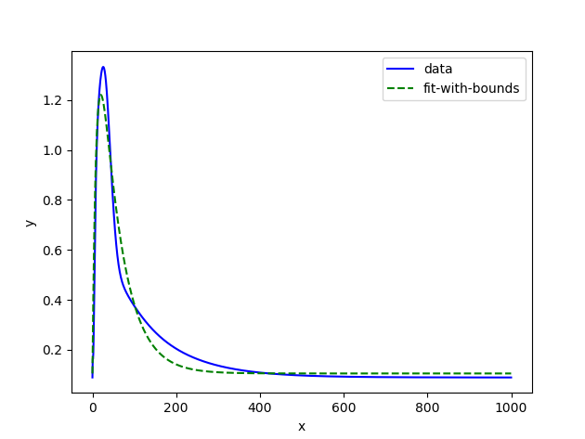

Starting Point (Original Bounds)

popt, pcov = curve_fit(func, time, data, bounds=([0., 0., 0.8, 0.01], [150., 200., 1.5, 0.4]))

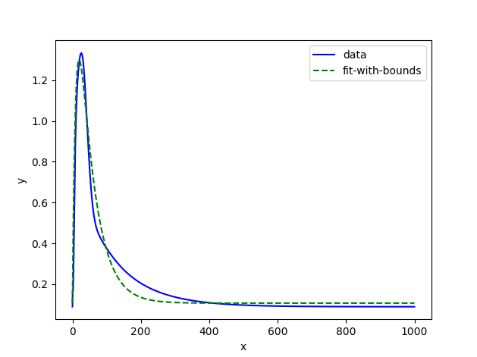

Changing the minimum Cai_amp value to 1.3 from 0.8

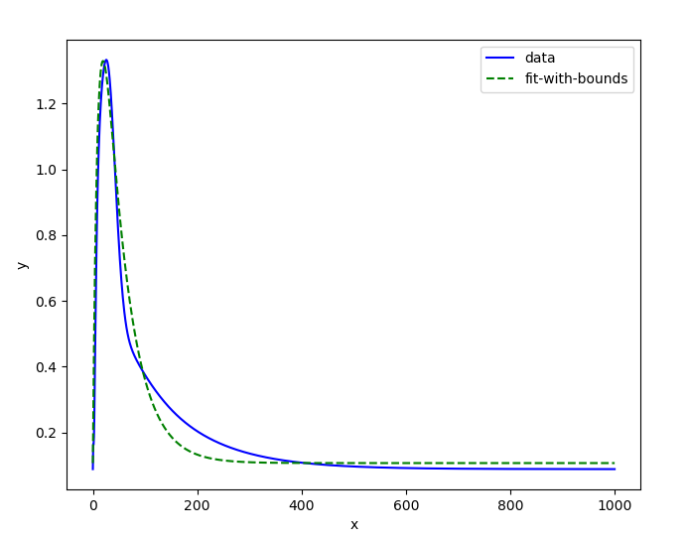

Changing the minimum Cai_amp value to 1.33 from 0.8